Chip back potential is the level which bulk silicon is maintained by on-chip connection, or it is the level to which the chip back must be connected when specifically stated below. If no potential is given the chip back should be isolated.

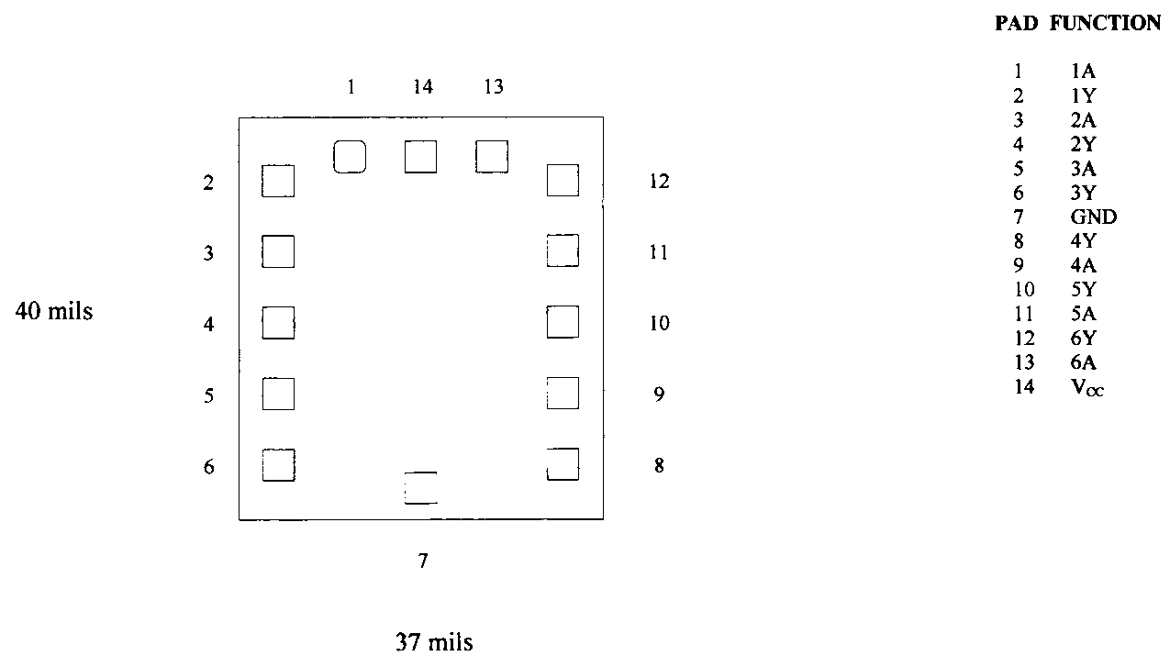

Top Material: Al
Backside Material: Si Ni
Bond Pad Size: .004” X .004”
Backside Potential: GND
Mask Ref: LS05C

APPROVED BY: DK DIE SIZE .037” X .040” DATE: 4/19/21
MFG: TEXAS INSTRUMENTS THICKNESS .025” P/N: 54LS05
DG 10.1.2

Rev B, 7/19/02

